**IS201 Fundamentals of Computing – Python**

**HOS02 – Python Data Type, Conversion, and Data Structure**

03/21/2024 Developed by Scott Zhou

04/01/2024 reviewed by Vaishnavi Mandage

School of Technology and Computing (STC) @City University of Seattle (CityU)

**Before You Start**

* Version numbers may not match the most current version at the time of writing. If given the option to choose between the stable release (long-term support) or the most recent, please select the stable release rather than the beta-testing version.
* Screenshots may be different from your environment.
* There might be subtle discrepancies along the steps. Please use your best judgment while going through this cookbook-style tutorial to complete each step.  For your working directory, use your course number. This tutorial may use a different course number as an example.
* The directory path shown in screenshots may be different from yours.
* If you are not sure what to do or confused with any steps:

1. Consult the resources listed below.
2. If you cannot solve the problem after a few tries, ask a TA for help.

**Learning Outcomes**

Students will be able to:

* Understand the Python data types and casting
* Understand the Arrays and Enums

**Create a Project**

Follow HOS1 to set up the project in Codespaces, or use any other code editor you prefer, such as Visual Studio, Visual Studio Code, Sublime, Vim, etc…

We will create a Python project to cover all the learning outcomes; the project simulates a library management system, which will store book categories as enum and store books in a list.

1. Create a Python file named HOS02.py
2. Import Enum from Enum; this will load the required module for this program; in this case, it is an enumeration.

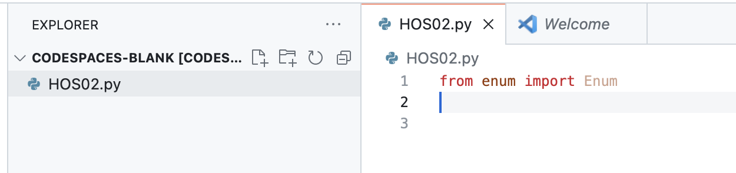

1. Define book categories using enumeration; there are four categories: fiction, nonfiction, educational, and children.

1. Define a book class consisting of title, author, and category.

1. Create a library class and initialize a list to store all the books.

1. Create two books to test if the list and enums work properly for books and book categories.



1. Create a third book to practice casting category numbers to category enum.

1. Initialize the library object and add all three books.

1. Call the display_books()method from the library to verify all the books have been added.



1. The expected output in the terminal after executing the program:



**Submit your Work to Brightspace**

Please upload your .py file to the HOS02 assignment on Brightspace.